- Launch one EC2 using Amazon Linux 2 image and add a script in user data to install Apache.
During the launching instance I have bootstrapped the process to install httpd by this script
#!bin/bash
Sudo -i
Yum install httpd -y
Systemsctl start httpd
Systemsctl status httpd

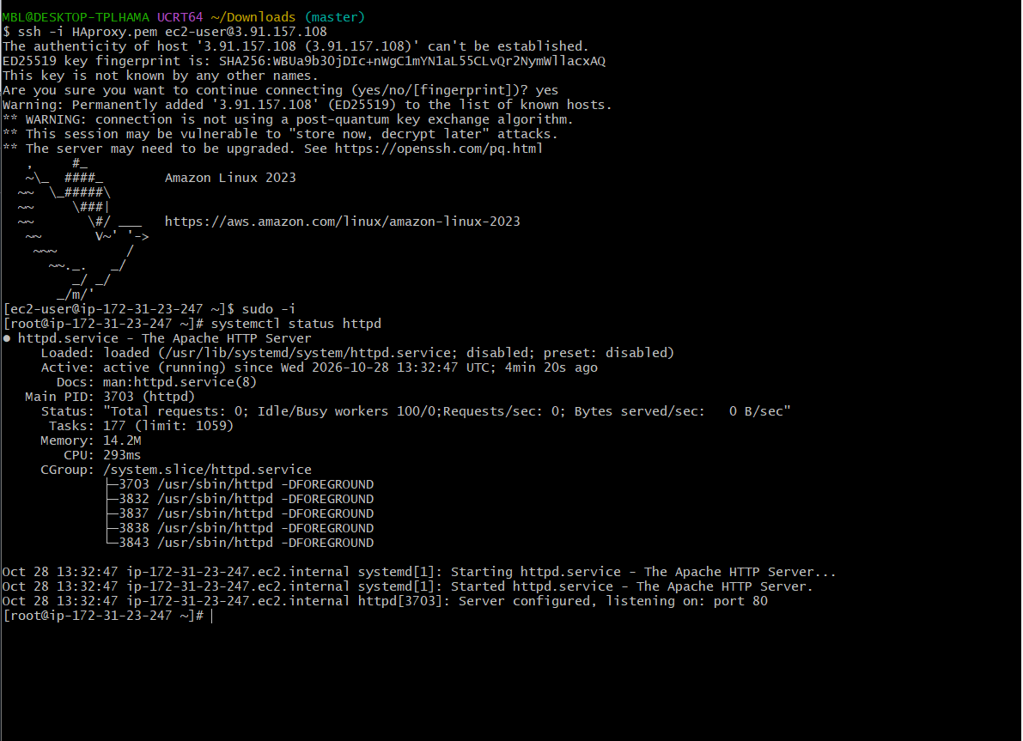
Hence successfully created the httpd page
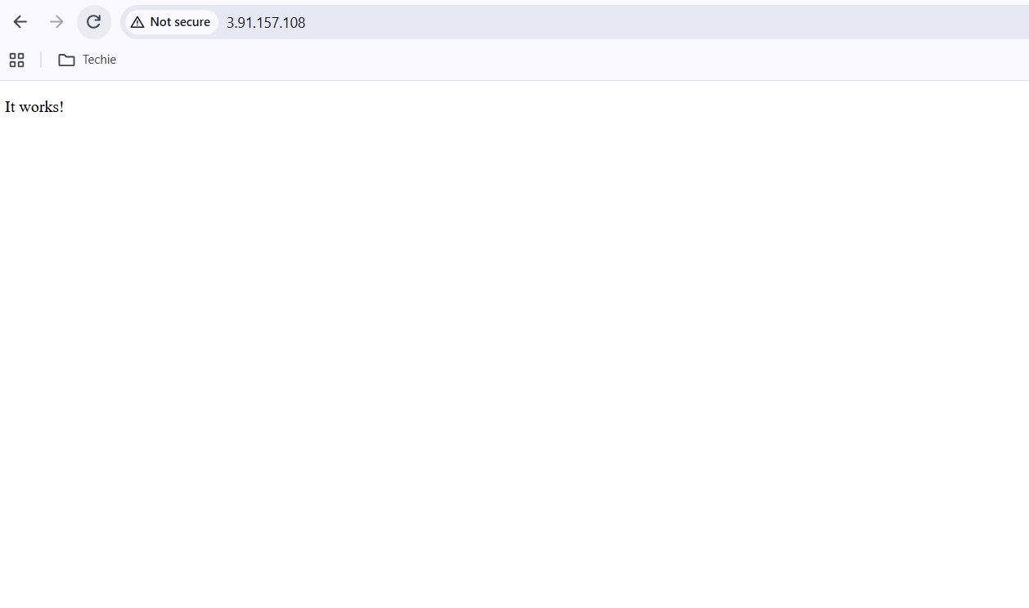

- Launch one EC2 using Ubuntu image and add a script in user data to install Nginx.
During the launching instance I have bootstrapped the process to install httpd by this script
#!bin/bash
Apt-get update
Apt-get install nginx -y
Systemsctl start nginx
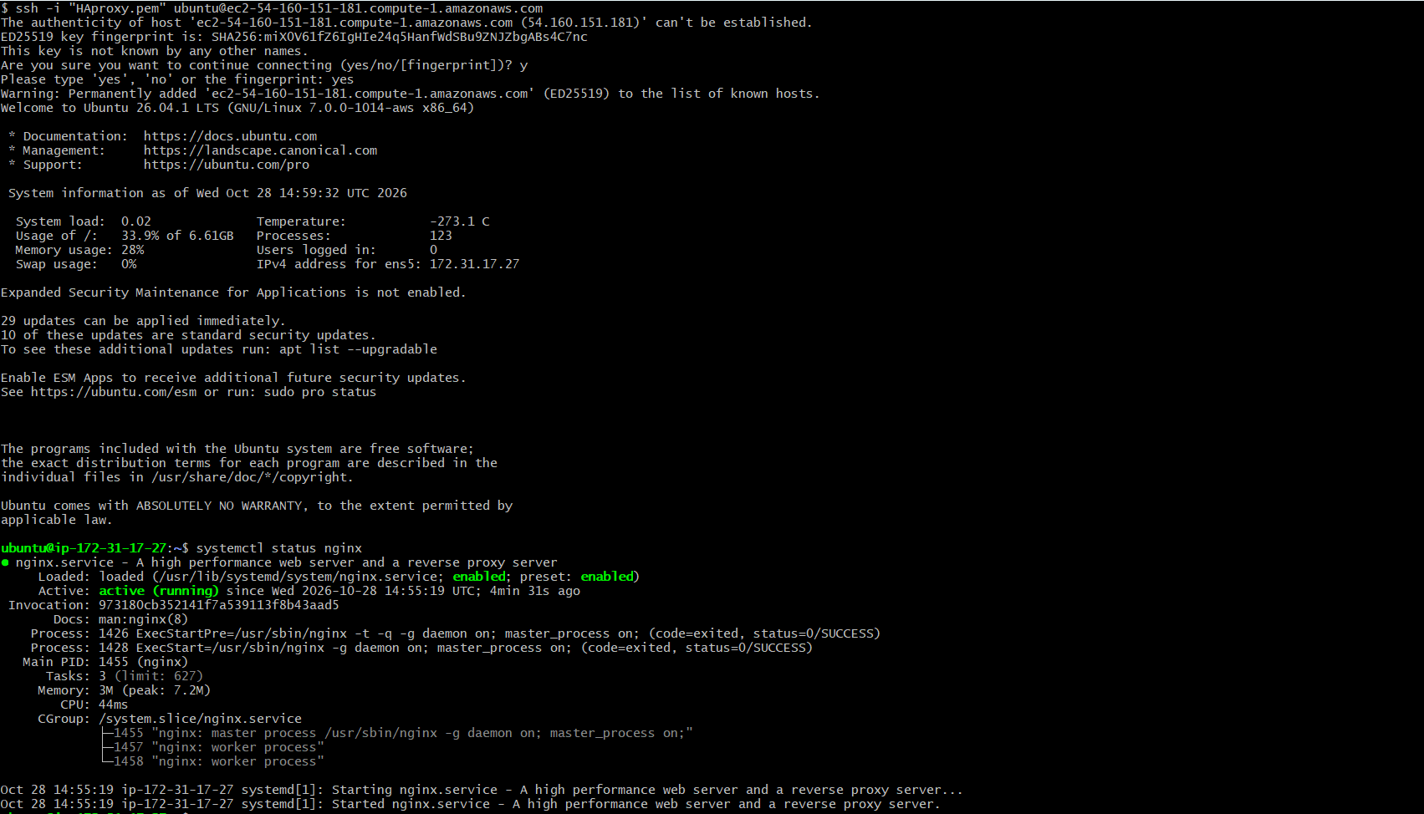

Hence successfully created the httpd page
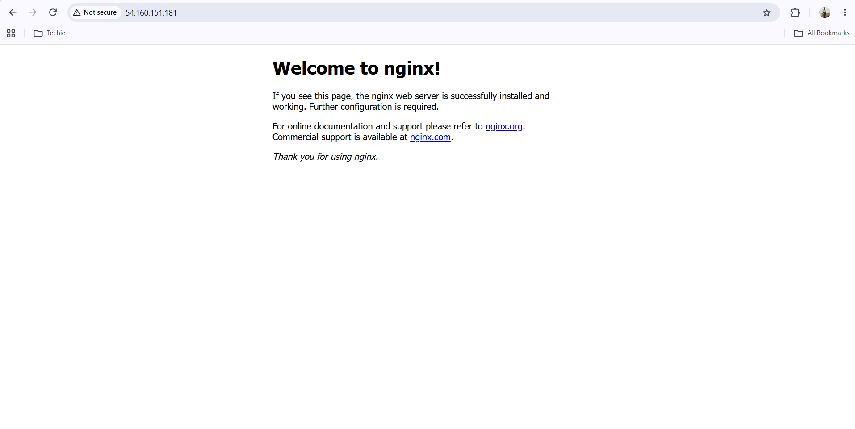

- Launch one Windows server and install Tomcat on Windows.
Setting the variables to save version, URL & path of a tomcat to automate my version and URL so that if any version came it can download automatic and also set the path from 3rd variable:
# Define variables
1.
$TomcatVersion = "10.1.24" # Update to latest stable if needed
2.
$DownloadUrl = "https://archive.apache.org/dist/tomcat/tomcat-10/v$TomcatVersion/bin/apache-tomcat-$TomcatVersion-windows-x64.zip"
3.
$InstallPath = "C:\Tomcat"

Downloaded zip file of tomcat 10 through URL in ‘C’ drive, the which I just set the path in above step
Invoke-WebRequest -Uri $DownloadUrl -OutFile "C:\tomcat.zip"

To extract the zip file:
Expand-Archive -Path "C:\tomcat.zip" -DestinationPath "C:\"

I wanted to rename the file name as tomcat, but it was already there so getting error
Rename-Item -Path "C:\apache-tomcat-$TomcatVersion" -NewName "Tomcat"

Then I created a Java DIR directory, then copied the java folder with his name and complete path and it will be pasted in the JAVA DIR to avoid full path and complete name details
$javaDir = Get-ChildItem "C:\Program Files\Eclipse Adoptium\" | Select-Object -First 1

It will guide the windows and tomcat to know about Java location so that they can find and run the services:
$env:JAVA_HOME = $javaDir.FullName

This is to go to Tomcat bin location to start the Tomcat service:
cd C:\Tomcat\bin

started Tomcat
.\startup.bat

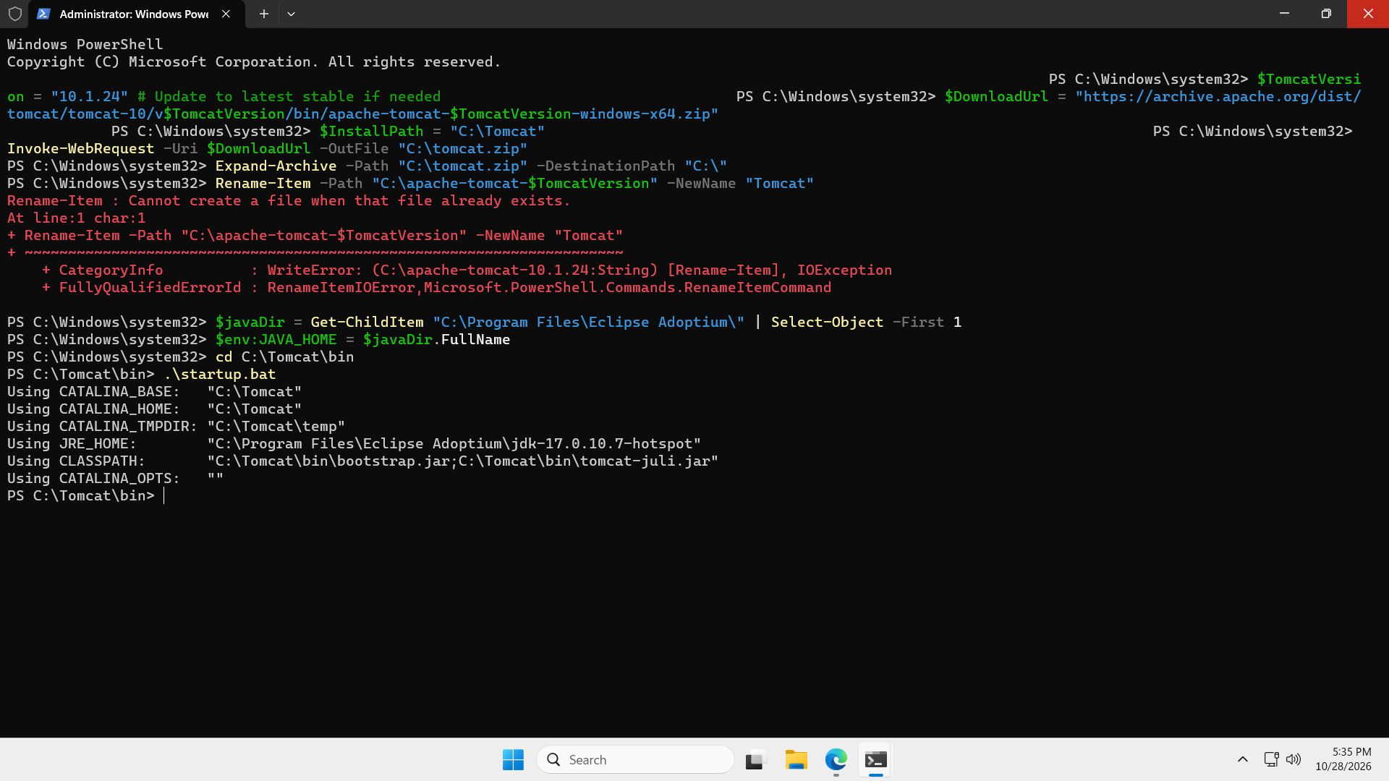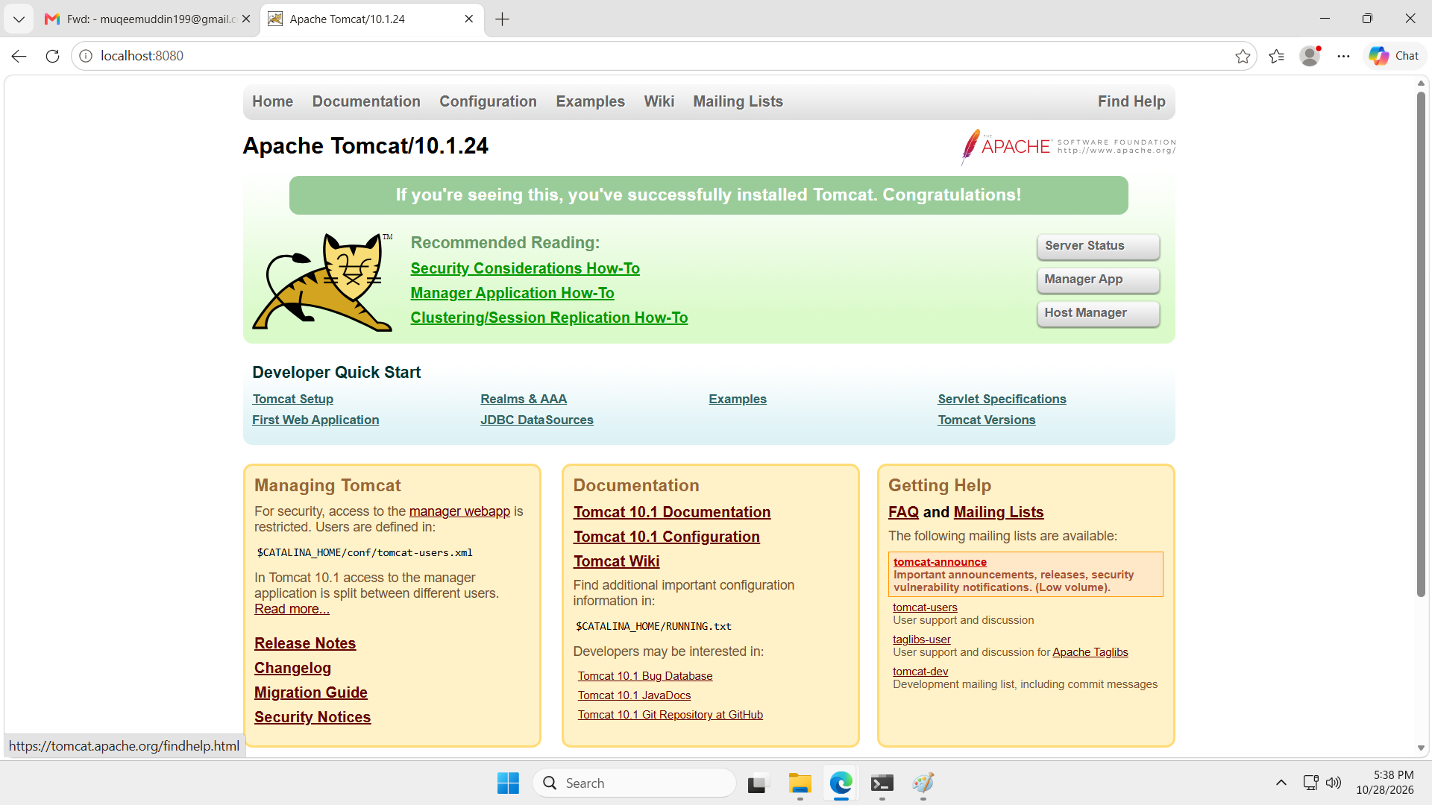

- Take a snapshot of the instance created in Task 1.
Path to create AMI/snapshot/backup instance:
Check to an instance > actions >image and templets> keep a name to backup > create backup instance>launch instance > my AMI’s > check the created AMI > create key gen
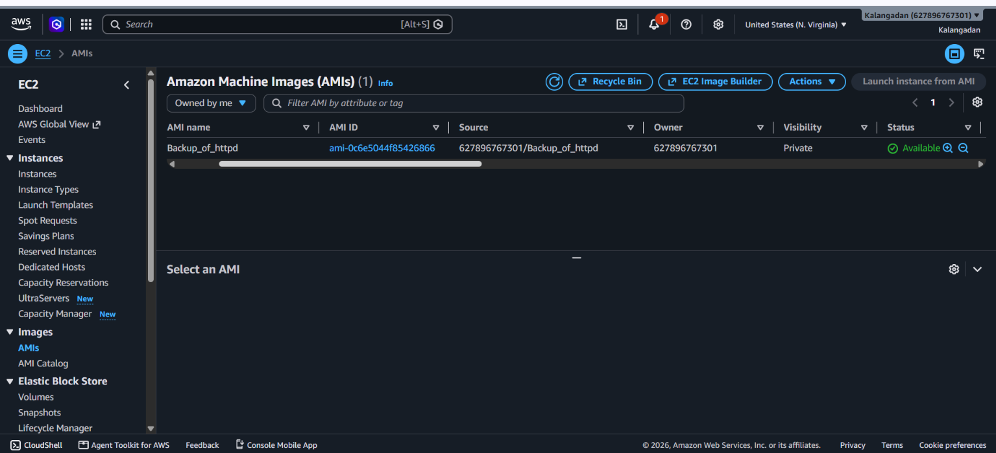
- Assign passwordless authentication for the EC2 created in Task 2.
Root user: ec2 instance> cd .ssh>vi authorized_keys >pasted the key here >(and also make a directory) sudo mkdir -p /home/tanveer/.ssh > sudo chown -R tanveer:tanveer /home/tanveer/.ssh > sudo chmod 700 /home/tanveer/.ssh> sudo chmod 600 /home/tanveer/.ssh/authorized_keys
User 2: ssh-keygen > cat /(location of key) > copied
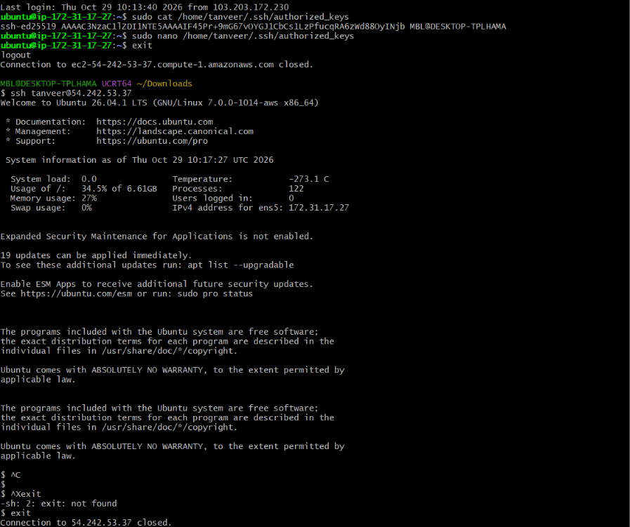
- Launch any EC2 using the spot purchasing option.
Selected the spot instance in the advanced section and launch the spot instance.
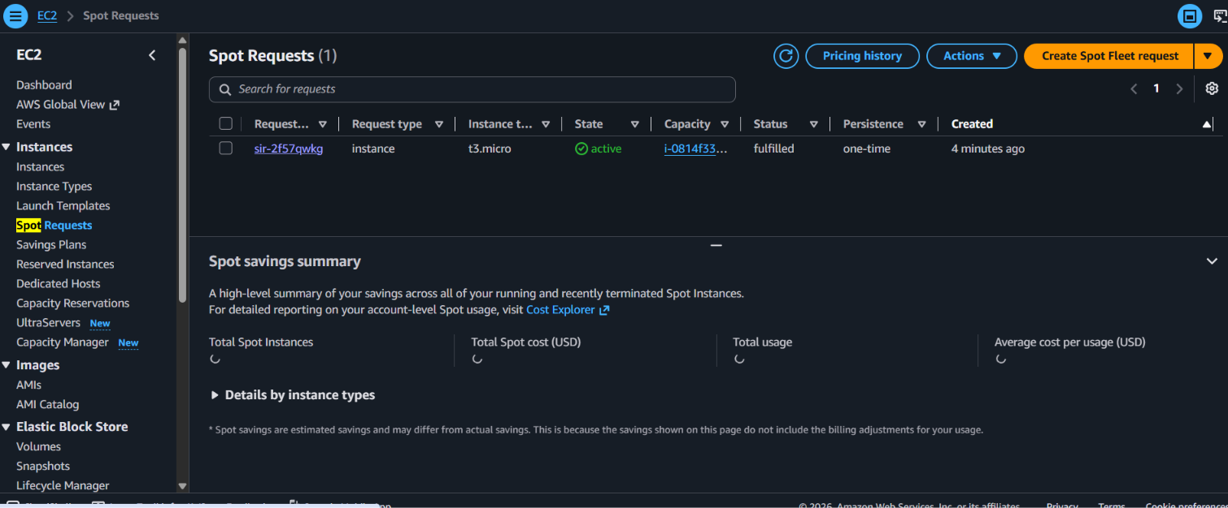
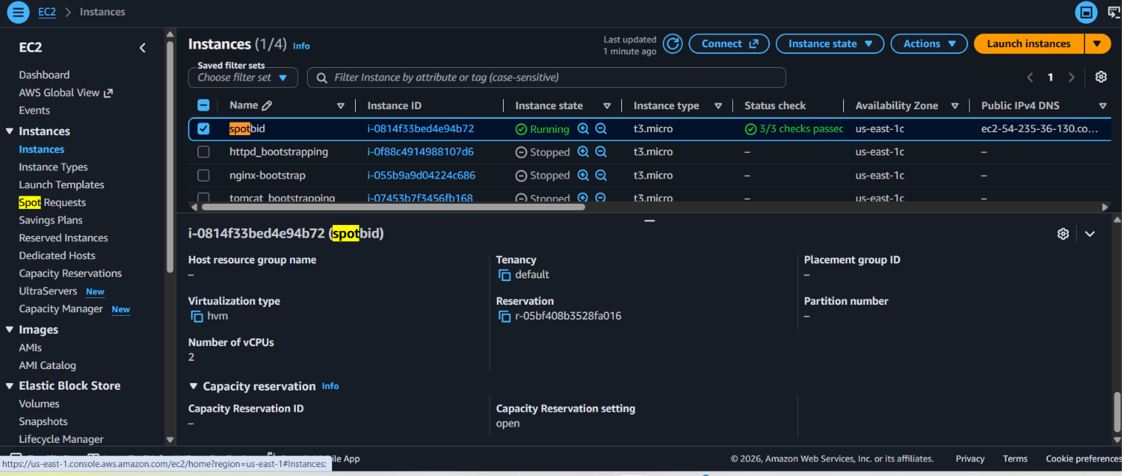
- Enable termination policy on the EC2 created in Task 2.
Select the instance > actions > change termination protection > checkbox the enable option > save this
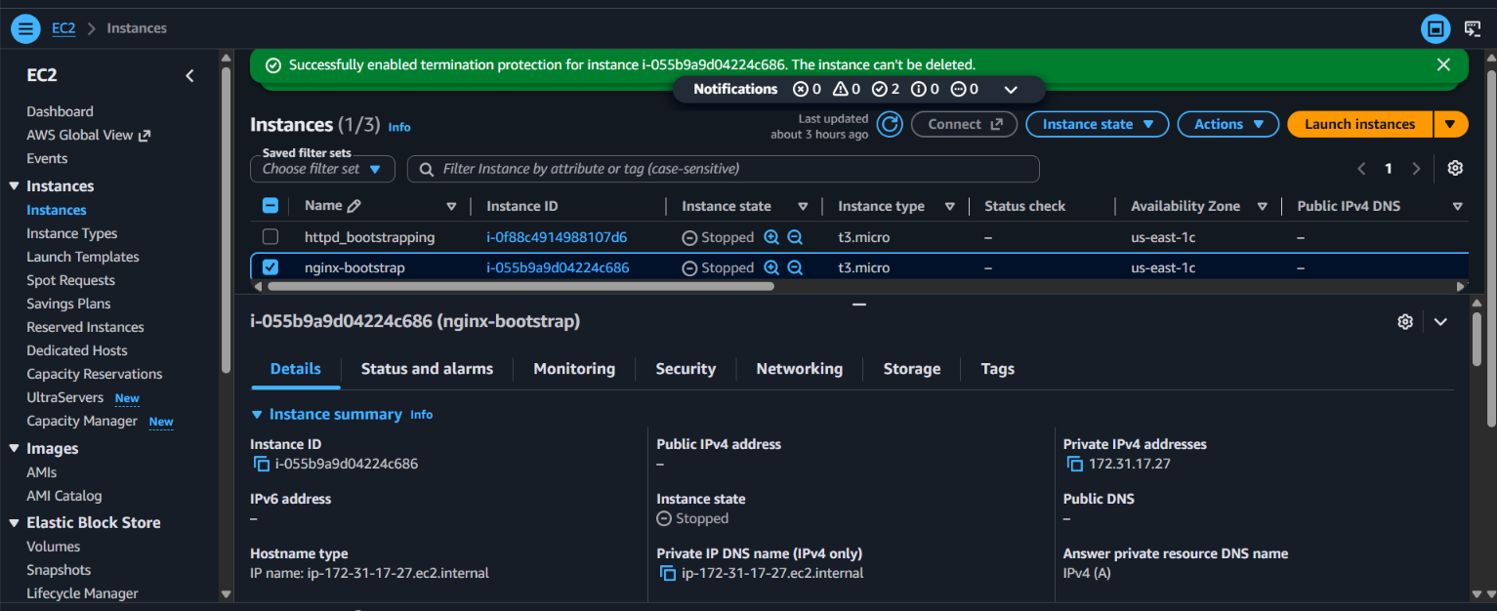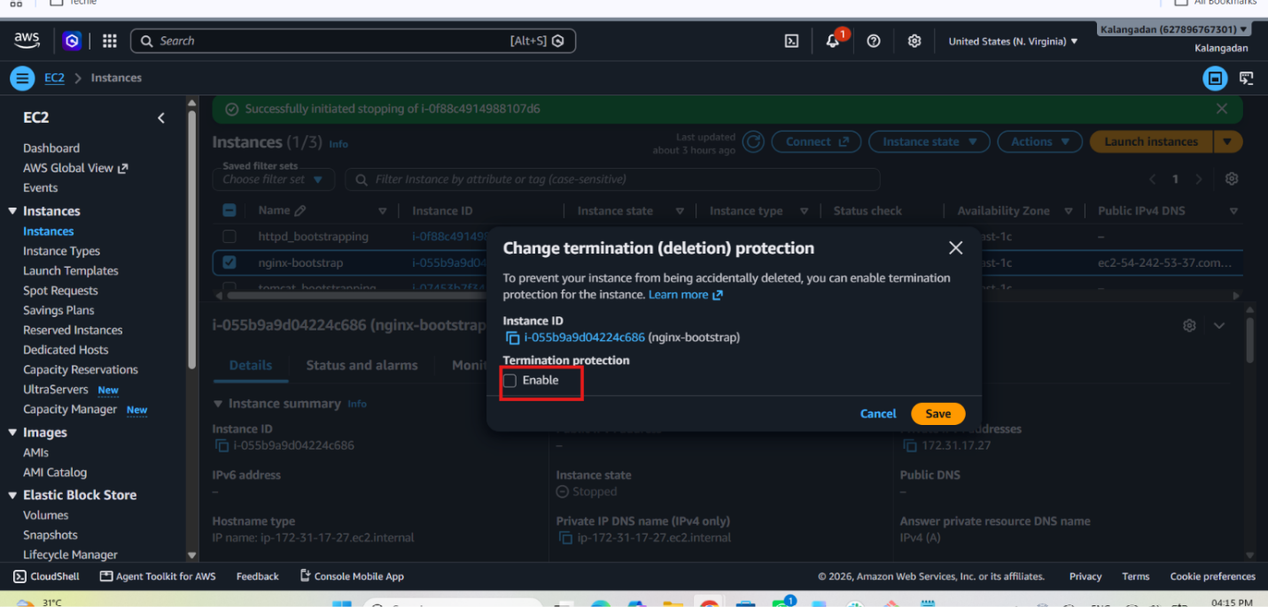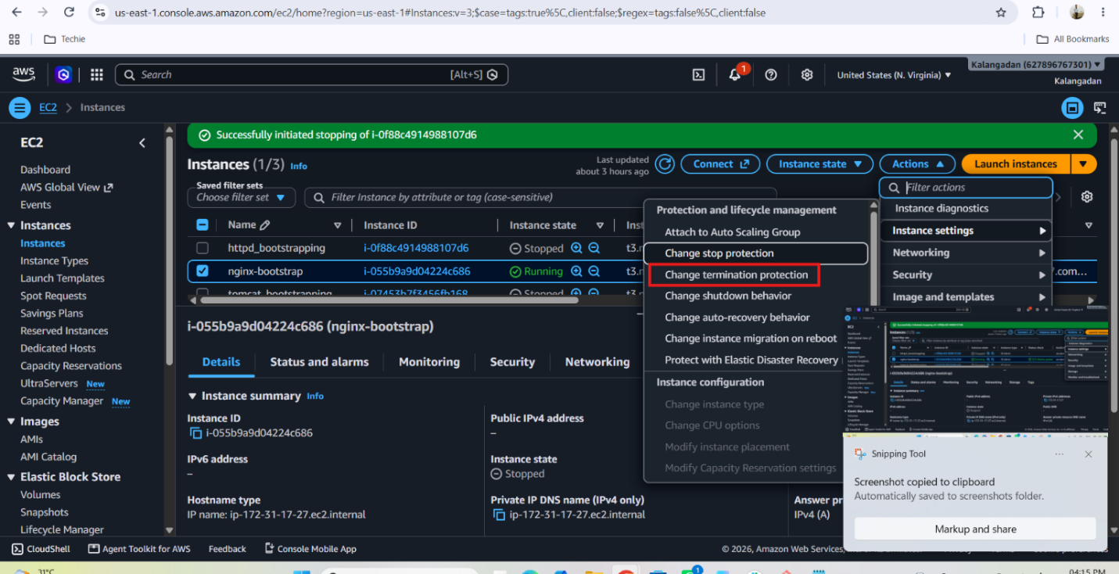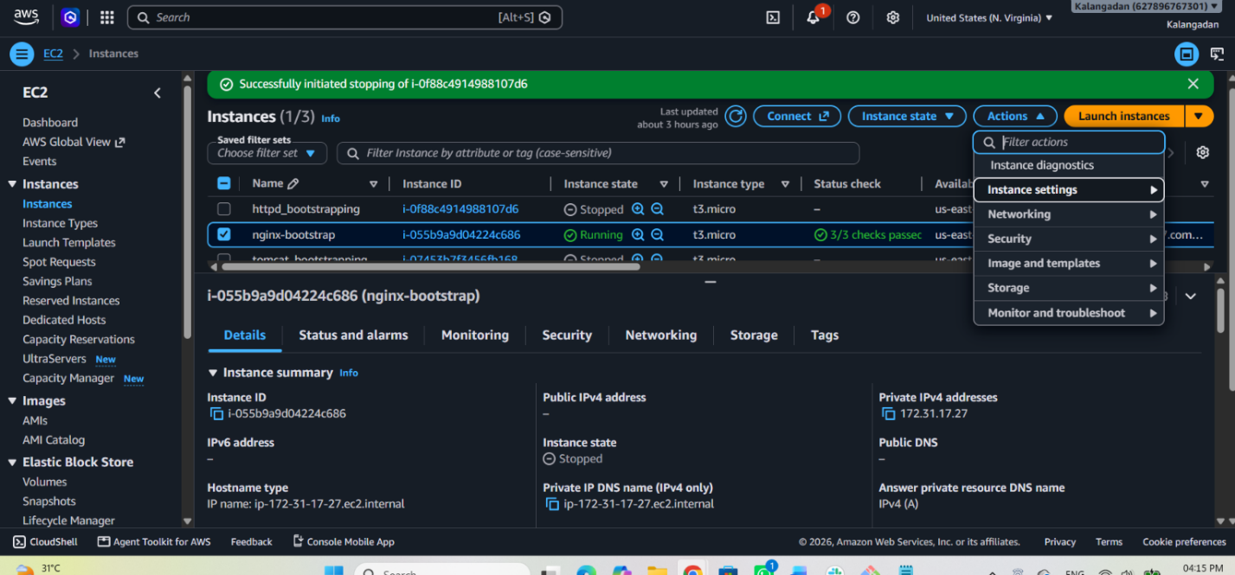
- Launch one EC2 using AWS CLI.
sudo apt install awscli # version 2.31.35-1 > aws –version > aws configure > > IAM(AWS)>roles>create roles>AWS servide & EC2 > AmazonEC2FullAccess > keep role name as “EC2-CLI-Role” >create role >> select the working instance > actions >security > modify IAM role > select “EC2-CLI-Role” >> Run the command on CLI “aws ec2 run-instances --image-id $(aws ec2 describe-images --owners amazon --filters "Name=name,Values=ubuntu/images/hvm-ssd/ubuntu-jammy-22.04-amd64-server-*" --query "Images[0].ImageId" --output text) --instance-type t2.micro --count 1”
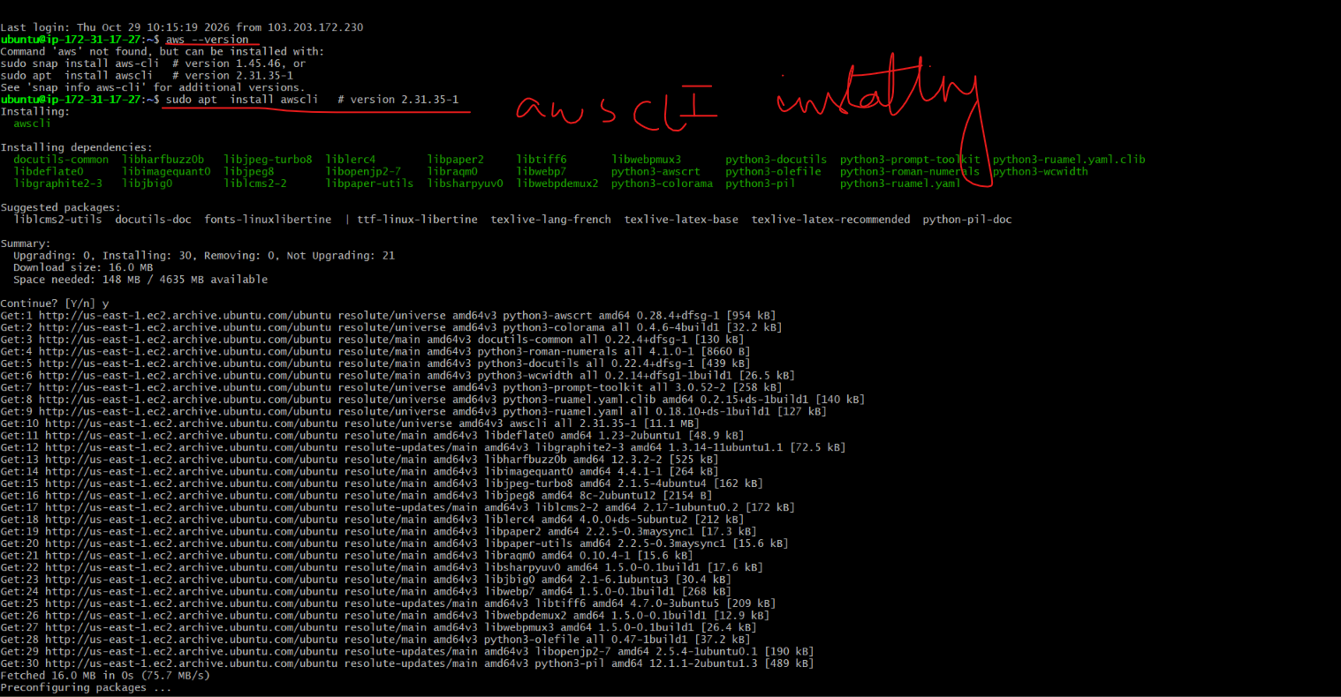
Then checked the version
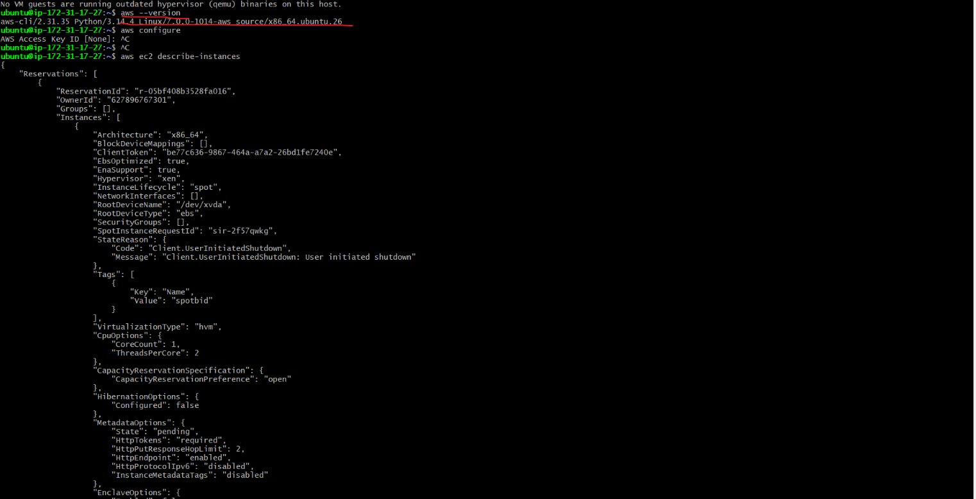
Then I didn’t configured the aws through IAM secret & access key but I modified the IAM roles and applied modifications on my running instance then executed this command on CLI
“aws ec2 run-instances --image-id $(aws ec2 describe-images --owners amazon --filters "Name=name,Values=ubuntu/images/hvm-ssd/ubuntu-jammy-22.04-amd64-server-*" --query "Images[0].ImageId" --output text) --instance-type t2.micro --count 1”
Then I got this message that not eligible on free tier
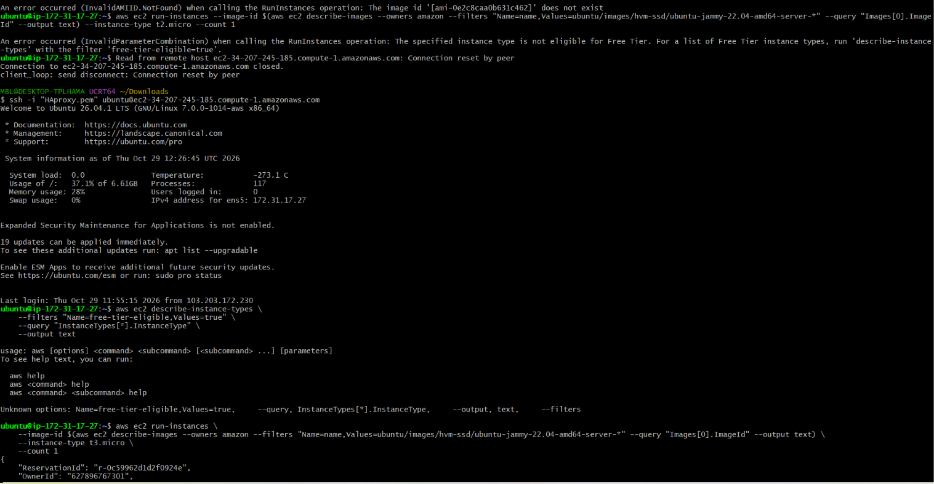
“An error occurred (InvalidParameterCombination) when calling the RunInstances operation: The specified instance type is not eligible for Free Tier. For a list of Free Tier instance types, run 'describe-instance-types' with the filter 'free-tier-eligible=true'.”
Then I applied for 2 commands on terminal
aws ec2 describe-instance-types \
--filters "Name=free-tier-eligible,Values=true" \
--query "InstanceTypes[*].InstanceType" \
--output text

aws ec2 run-instances \
--image-id $(aws ec2 describe-images --owners amazon --filters "Name=name,Values=ubuntu/images/hvm-ssd/ubuntu-jammy-22.04-amd64-server-*" --query "Images[0].ImageId" --output text) \
--instance-type t3.micro \
--count 1

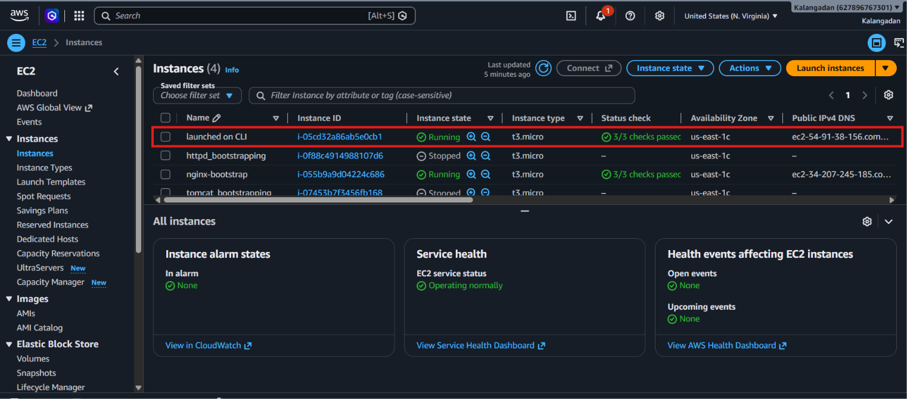
To check the instances list on CLI
aws ec2 describe-instances --query "Reservations[].Instances[].{InstanceId:InstanceId,State:State.Name}" --output table

To stop the instance on CLI
aws ec2 stop-instances --instance-ids i-YOUR_ACTUAL_ID_HERE

